# CHAPTER 1

**ORGANIZATION PROFILE**

* 1. **INTRODUCTION**

The following report describes the activities carries out during a 4-week, full time internship in RaRo Technologies Private limited. The document contains information about the organization and the responsibilities performed throughout the internship period. More than a plain account of tasks, the objective of this text is to reflect upon the experiences collected during the internship from the perspective of a BE student.

The first part of the report offers about the organization, followed by the working plan initially agreed upon with the Federation and approved by the University of VTU as a suitable internship. Following, it proceeds to describe in some detail about the Department and the most relevant Task performed. Finally, the report ends with reflection notes.

**1.2 OVERVIEW OF ORGANIZATION**

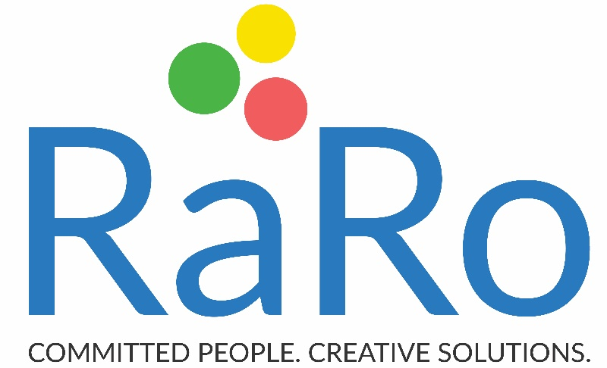

RaRo is the next generation Digital Transformation Company, guided by over 100+ years of collective IT industry experience. They are expertise Lead & Culture backed team to build memorability with our People, Customers and Society at large. The company has many demonstrated experiences of building high performance teams to deliver value to customers.

The word RaRo means extraordinary & is the state of being bound passionately, emotionally, intellectually to an action-oriented result. It is glue that bonds with overall goals and unlocks the doors of imagination to create extraordinary outcomes. An action committed towards People, Customers & Society. Results starts with a Right choice & is sustained by dedication, perseverance, passion for excellence. It is expressed, realized in thoughts, intentions & actions. RaRo is committed to transforming a challenge into a reality to deliver creative solutions for customer success.

**1.3 VISION OF ORGANIZATION**

To become a leading performer and grow as a major IT service provider, providing quality Web application, Software Development solutions and corporate training in the competitive global marketplace.

**1.4 MISION OF ORGANIZATION**

To ensure strategic planning with quality products and profitable growth through customer service, innovation, quality and commitment.

## CHAPTER 2

**ABOUT THE COMPANY**

RaRo Technologies has evolved a Talent Development Framework which is based on analysis of skill gap, skill requirements by the industry & skill assessment at the academic’s level. This framework has been designed by RaRo Technologies professionals who have deep industry experience in various spears like Human Resources, Embedded software Development, Testing and Validation.

RaRo Technologies has developed a unique learning & assessment methodology, custom designed for students based on pre-assessment results. This will include customized curriculum, assessment patterns & improvement enablement. This content will be delivered by RaRo Technologies professionals at college premises.

​

RaRo Technologies has plans for continued engagement with student community through various communication channels such as online chat, skype, whatsApp, micro blogging, email communication etc. This will provide an opportunity for students to continue to do the assessments for industry readiness & also will help RaRo Technologies to continuously measure the effectiveness of the program delivered.

​

RaRo firmly believes in diversity of skill levels & improvement needs. They design customized modules & delivery methods most suitable for a particular student community. This is  in contrast to generic training programs which employ “One content fits all” approach. Our team has comprehensive understanding & assessment of current skill levels of the students at engineering colleges. This understanding has been derived from end to end experience of handling Campus Talent Acquisition & Development on real time basis for leading colleges &corporate houses.

​

RaRo has highly experienced facilitators in various streams having track record of delivering quality programs for multiple Institutes & corporate houses.  RaRo is roaring for the last 5 years and delivered quality programs to more than 15,000 students across various Engineering/MBA colleges in Karnataka.

**Company Details**

|  |  |
| --- | --- |
| CIN | U74999KA2017PTC099303 |
| Company Name | RaRo Technologies |
| Company Status | Active |
| RoC | RoC-Bangalore |
| Registration Number | 999303 |
| Company Category | Company limited by shares |
| Company Sub Category | Non-govt company |
| Class of Company | Private |
| Date of Incorporation | 19th January 2017 |
| Age of Company | 2 Years, 0months, 24 days |

**Table no 2.1: About company details**

**Why RaRo Technologies**

**Confidentiality:**

The work they do for their clients will not be shared or discussed with any other clients. They respect their privacy and will help it remain the same.

**Quality Policy:**

RaRo is committed deliver and maintain high standard product and services. Our reputation is directly proportional to our product and service, and they safe guard it by interacting with all members of the RaRo community in a consistent manner.

**Service & Support:**

In a world run by internet, they are just a click away. As of the company, client satisfaction is a number one priority. They always concentrate on providing enhanced world-class solutions to their clients.

RaRo Talent Solutions is at the at the heart of talent identifying, nurturing, mentoring & managing Human Capital. Our mission is to Transform Talent as a true Global Talent making quality education to young Indians and experienced learners who aspire to develop their employability quotient in the ever-changing global marketplace. Our unique LMWTM framework which facilitates life changing experiences among young talent.

​

The company’s competency development initiatives for academics/industries meet all possible needs of the management, students and the industries looking for highly skilled & industry ready talent. They conduct skill/competence development programs that significantly increases the career opportunities of students, assuring a high-flying career, enhanced branding for the Academia/ Universities/ colleges. All our programs are open for customization depending on the needs, time availability of our customers.

**Technical Expertise:**

They carry out solutions with conventional knowledge in the technical aspects. This helps them cater their client’s needs with superior results.

**Company products and services:**

* Software and Product Development Services.
* Software Maintenance Services.
* Verification and Validation Services.
* Tech Support Services.
* Talent Solutions

**Team/Department Overview:**

* RaRo Technologies is a team of experienced professionals providing a wide range of complex software and web application development services.
* The energetic professionals with vast experience who are working in almost all technologies & spheres of IT.

## CHAPTER 3

## TASK PERFORMED

**3.1 TRAINING PROGRAM**

**HTML AND CSS**

HTML stands for Hyper Text Mark-up Language. It is the standard mark-up language for creating Web pages. It describes the structure of Web pages using mark-up. With Cascading Style Sheets (CSS) and JavaScript, it forms a triad of cornerstone technologies for the World Wide Web.

Web browsers receive HTML documents from a web server or from local storage and render the documents into multimedia web pages. HTML describes the structure of a web page semantically and originally included cues for the appearance of the document.

HTML elements are the building blocks of HTML pages. With HTML constructs, images and other objects such as interactive forms may be embedded into the rendered page. HTML provides a means to create structured documents by denoting structural semantics for text such as headings, paragraphs, lists, links, quotes and other items. HTML elements are delineated by tags, written using angle brackets.

CSS (Cascading Style Sheets) are used for describing the look and formatting of a document written in a mark-up language. It is simple text file or text embedded in the head of an HTML document. CSS is a style language that defines styles (example. fonts, colours, spacing) and layout of web pages written in HTML/XHTML and XML. The difference between CSS and HTML is that HTML/XHTML is used to structure content and CSS is used for formatting structured content.

**PHP**

PHP is an acronym for "PHP: Hypertext Pre-processor”. PHP is a server scripting language, and a powerful tool for making dynamic and interactive Web pages. It is a widely used, open source scripting language. It is free to download and use.

PHP files can contain text, HTML, CSS, JavaScript, and PHP code. PHP code are executed on the server, and the result is returned to the browser as plain HTML.PHP files have extension " php ".

PHP code may be embedded into HTML or HTML5 markup, or it can be used in combination with various web template systems, web content management systems and web frameworks. PHP code is usually processed by a PHP interpreter implemented as a module in the web server or as a Common Gateway Interface (CGI) executable. The web server software combines the results of the interpreted and executed PHP code, which may be any type of data, including images, with the generated web page. PHP code may also be executed with a command-line interface (CLI) and can be used to implement standalone graphical applications.

PHP can generate dynamic page content. It can create, open, read, write, delete, and close files on the server, collect form data, can send and receive cookies, can add, delete, modify data in your database, and can be used to control user-access. It can encrypt data.

With PHP you are not limited to output HTML. You can output images, PDF files, and even flash movies. You can also output any text, such as XHTML and XML.

**3.2 PROJECT**

**Overview**

The project HealthCare system includes registration of patients, storing their details into the system, and also computerized billing in the pharmacy, and labs. The system has two clinical type i.e.; Single clinic and poly clinic. A single clinic is a [clinic](https://en.wikipedia.org/wiki/Clinic) or [health care facility](https://en.wikipedia.org/wiki/Health_care_facility) that provides only general examinations to [the patients](https://en.wikipedia.org/wiki/Outpatient). A polyclinic is a [clinic](https://en.wikipedia.org/wiki/Clinic) or [health care facility](https://en.wikipedia.org/wiki/Health_care_facility) that provides both general and specialist examinations and treatments for a wide variety of diseases and injuries to [outpatients](https://en.wikipedia.org/wiki/Outpatient) and is usually independent of a hospital. The system has four modules and they are admin, doctor, reception and nurse. And each module has a separate interface to access, alter, add and delete the information about the patient. The nurse module has an interface where the nurse can update the results of vital test performed on patients, view patient details, add patient details of an already existing patient, add new patient and allocate an appointment with the particular doctor based on severity.

The system has the facility to give a unique id for every patient and stores the details of every patient and the staff automatically. It includes a search facility to know the current status of each room. User can search availability of a doctor and the details of a patient using the id. The Health Care System can be entered using a username and password. It is accessible either by an administrator or receptionist. Only they can add data into the database. The data can be retrieved easily. The interface is very user-friendly. The data are well protected for personal use and makes the data processing very fast. Hospital Management System is powerful, flexible, and easy to use and is designed and developed to deliver real conceivable benefits to hospitals. Health Care System is designed for multi-speciality hospitals, to cover a wide range of hospital administration and management processes. It is an integrated end-to-end Health Care System that provides relevant information across the hospital to support effective decision making for patient care, hospital administration and critical financial accounting, in a seamless flow.

**Project Description**

Medical Health Care System for SIMS (structured inventory of malingered Symptoms) is used to easily track the information of all the staffs, patients, treatment provided, and prescription and also to generate periodic reports for analysis.

* The main goal of the software is to build a good management tool.
* The main purpose of this software is to reduce the time taken through manual system in order to maintain all the records.
* The project HealthCare system includes registration of patients, storing their details into the system, and also computerized billing in the pharmacy, and labs.
* The software has the facility to give a unique id for every patient and stores the details of every patient and the staff automatically

**3.3 Requirement Specification**

**3.3.1 Software requirements:**

* Operating System Windows XP, Windows7, onwards
* Language java
* Database MySQL
* Browser Chrome, Fire Fox, etc
* Web Server Tomcat server
* IDE Eclipse

**3.3.2 Hardware requirements:**

* Processor Pentium 4, i3, i5 & Above
* RAM 2 GB or More
* Hard disc 40GB or More

**3.4 RESULTS**

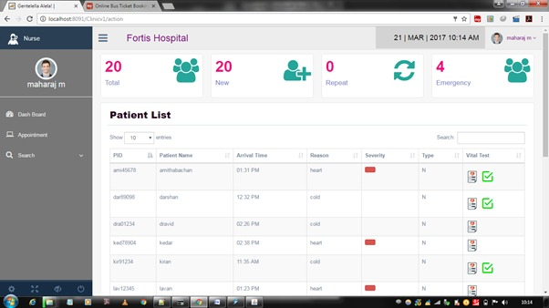

**Fig 3.4.1 Nurse Dashboard of single clinic type**

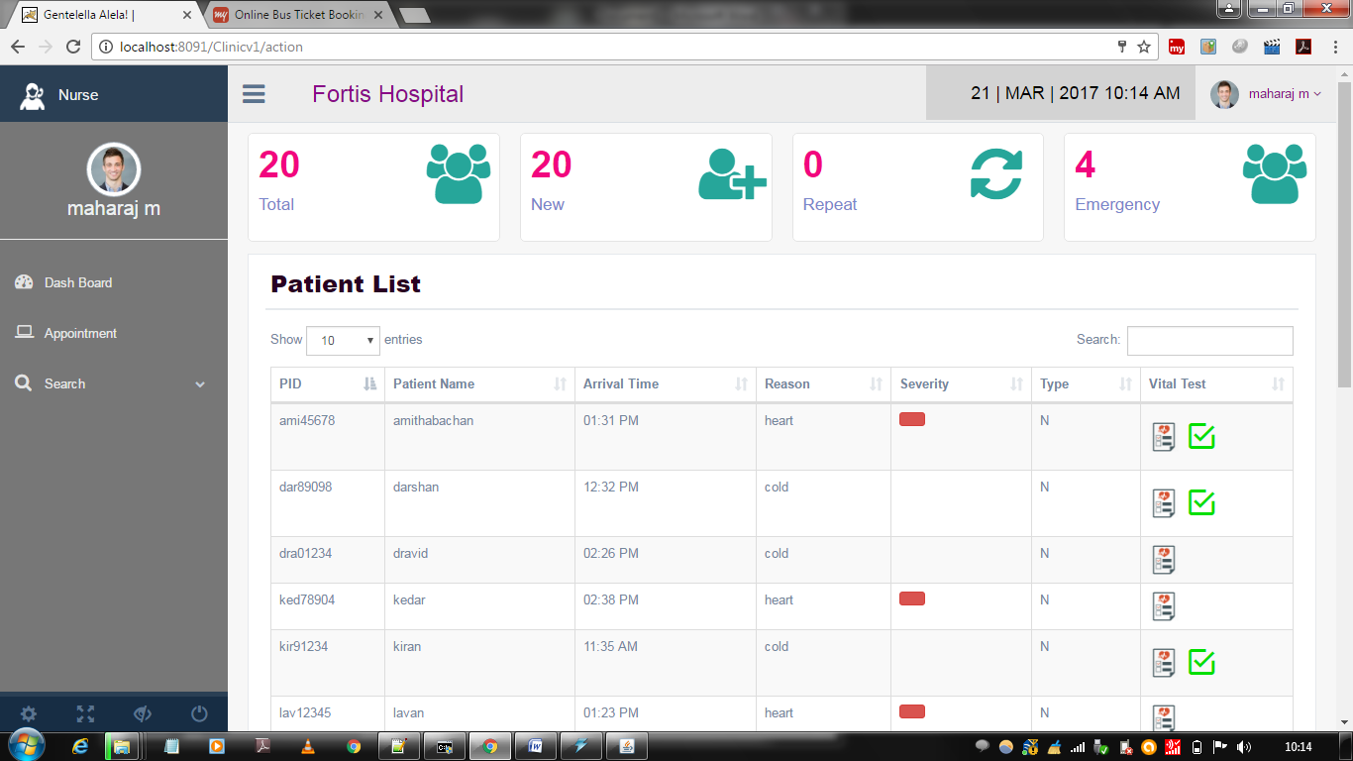

**Fig 3.4.2 Nurse dashboard for checking the vital test to be performed in single clinic type**

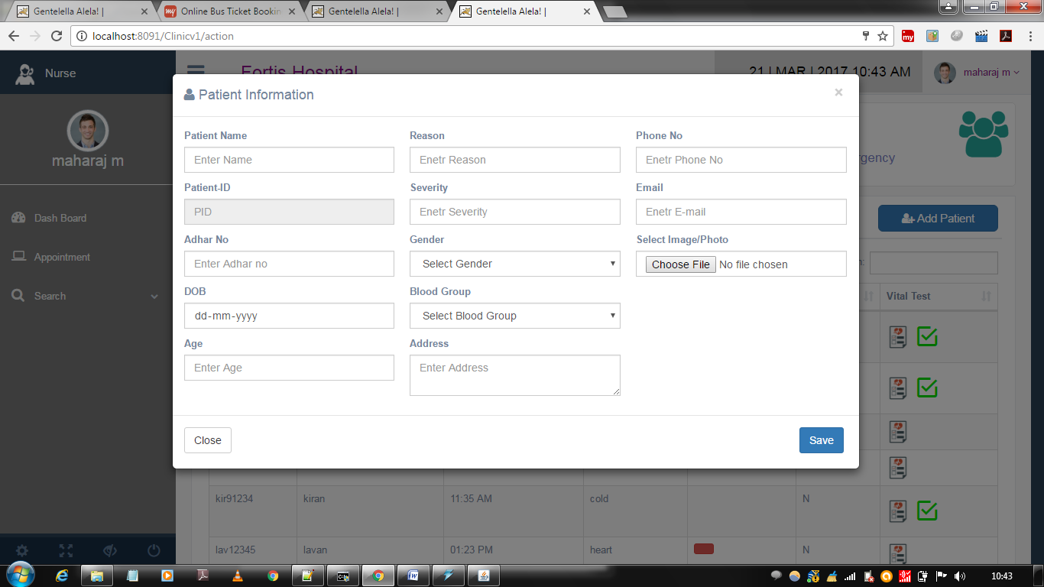

**Fig 3.4.3 Nurse dashboard for adding new patient by clicking on add new patient option in single clinic type**

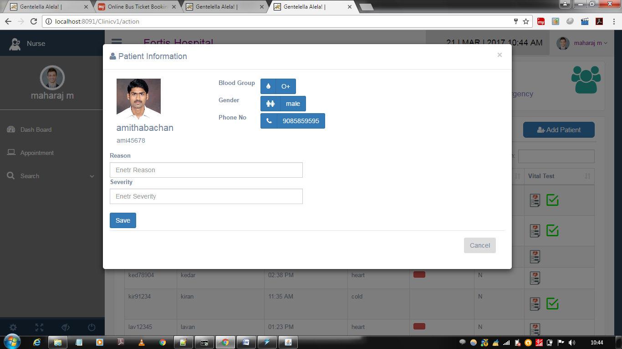

**Fig 3.4.4 Nurse dashboard for adding repeat patient by clicking on repeat patient option in single clinic type**

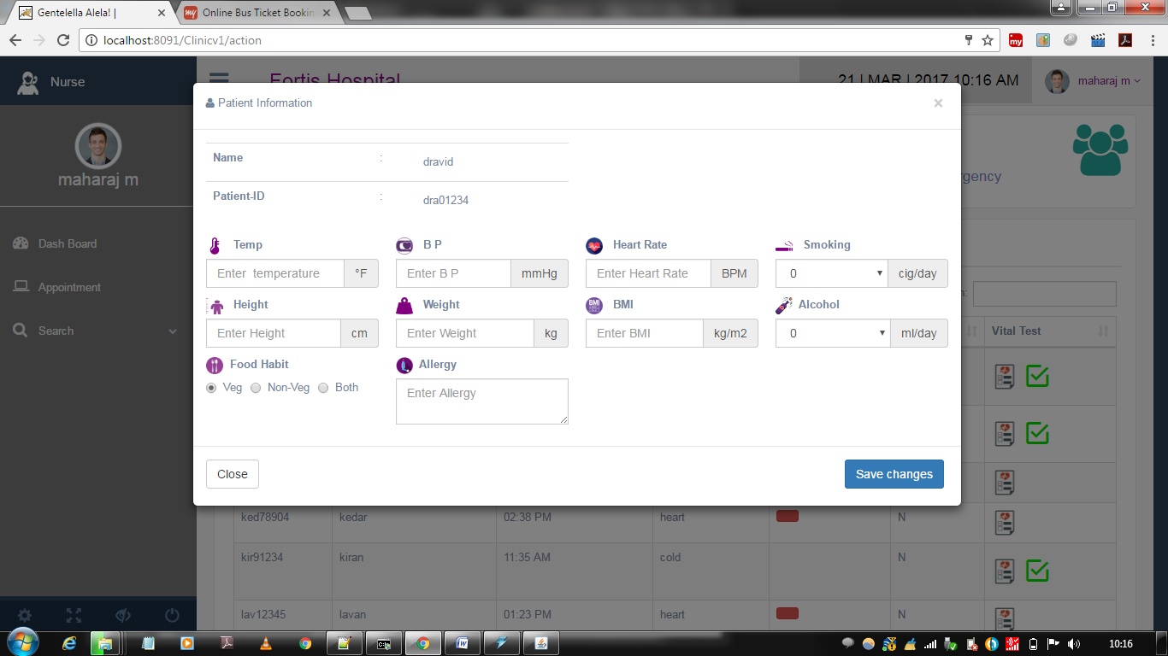

**Fig 3.4.5 Nurse dashboard for saving vital test information in single clinic type**

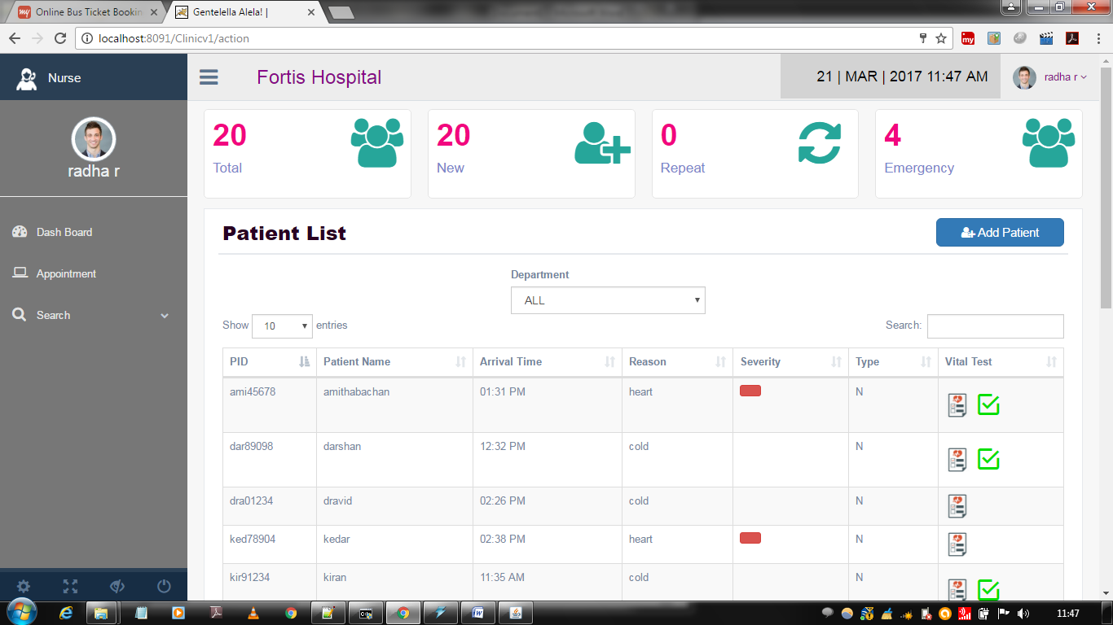

**Fig 3.4.6 Nurse Dashboard of polyclinic type**

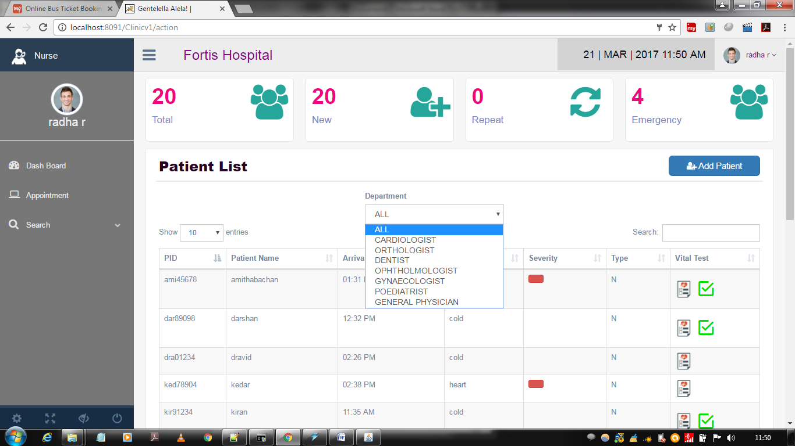

**Fig 3.4.7 Nurse dashboard for checking discipline wise patient list and nurse can check the vital test to be performed in polyclinic type**

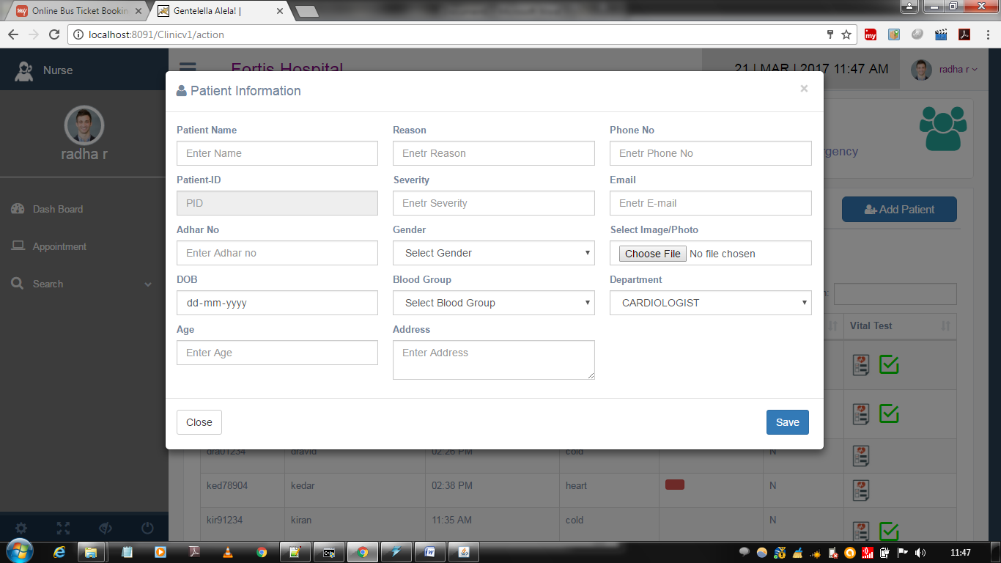

**Fig 3.4.8 Nurse dashboard for adding new patient by clicking on add new patient option in polyclinic type**

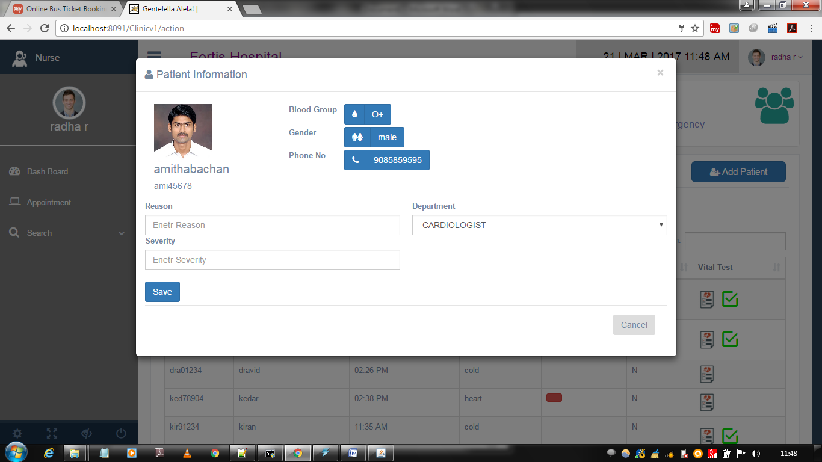

**Fig 3.4.4 Nurse dashboard for adding repeat patient by clicking on repeat patient option in polyclinic type**

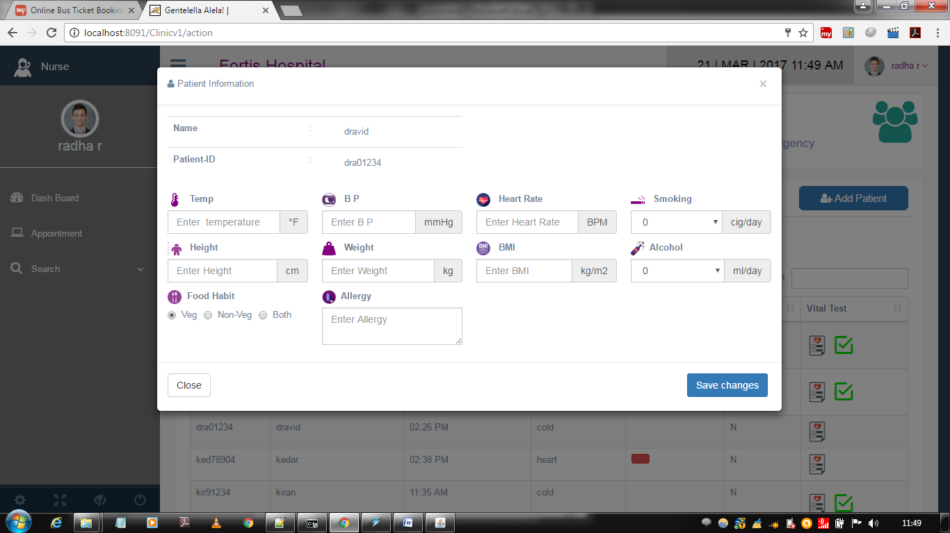

**Fig 3.4.10 Nurse dashboard for saving vital test information in polyclinic type**

**CHAPTER 4**

**REFLECTION NOTES**

My Internship at the RaRo technologies began in July and went on for about a month, I was required to apply my skills of html, CSS and php to comprehend the working. It was great experience learning a lot about domain which I was not well-known. In my internship I learnt out about web application development and furthermore under the direction of Mr Vijit and worked on project Medical Health Care System for SIMS (organized stock of malingered Symptoms), which is utilized to effortlessly follow the data of the considerable number of staffs, patients, treatment gave, and prescription and furthermore to produce periodic reports for analysis. Project duration ran for two or three hours throughout a month. There were tutors on whom I can depend on for help and support when I came some mistake.

The general experience was great. I took in a great deal of things, it truly helped me improve both specialized and non-specialized skills. My guide conveyed the ideas in a powerful manner and totally the feeling was generally excellent.

I would like to whole heartedly thank the company for taking me as an intern in the organization, Global Academy of Technology for allowing the chance to do this internship.

**CHAPTER 5**

## CONCLUSION

Doing the internship was very interesting and it helped acquire knowledge about the full stack development. It also helped me improve my technical skills on web application. The internship experience helped me improve my communication skills and how to work and interact in a team. It also improved the efficiency to acquire knowledge and complete the task in a limited number of times.

**REFERENCES**

[1] <https://www.w3schools.com/html/>

[2] <https://www.w3schools.com/css/>

[3] <https://www.geeksforgeeks.org/php/>

[4] <https://www.wikipedia.org/>